**CMPE-277: Smartphone application Development**

**Android Individual Application – Location Tracker**

**Submitted to:** Prof. Chandrasekar Vuppalapati

**Submitted by:** Anvit Saxena (SJSU ID: 010953436)



**Abstract**

This application is a SMS based GPS tracker that tracks the location of any particular phone in which application is installed. This application is developed thinking about the user’s security as an individual or of a loved one. Security is the major concern for every individual whether its personal security or any form of it. Thus, whenever you feel like you are lost or you want to have a look at your present location or any particular person’s location you can have that at your ease with this application.

**Introduction**

This project provides a solution with the use of a mobile phone for monitoring a SMS-based GPS tracker. The application is installed in any android smartphone and any other person’s mobile number is entered at the start of the application. Thus, the person whose mobile number is entered will receive the periodic location updates of the phone in which android application is installed. The location will be sent via a SMS and will consist of entire address as well as latitude and longitude of the location. This way a person might track a location of his loved one or a family member if needed. This application can also be used as a tracking device in any crime related matters. Below diagram shows the overview of the application:

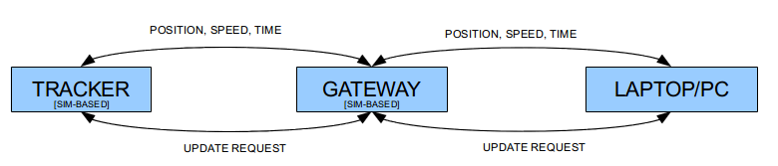

**Android Features Used**

I have developed this application using many android classes and features. Some of them are given below:

**Intents:** An intent provides an activity or a service with the capabilities of the actions and what type of broadcasts a receiver can handle. It is an abstract description of an operation to be performed.

**Services:** A service is started when an application component, such as an activity, starts it by calling startService(). Once started, a service can run in the background indefinitely, even if the component that started it is destroyed. In this application, the background activity plays an important role as the application keeps running in the background even when the user is using other applications.

**Maps:** Android Locations and Maps is used to provide latitude and longitude of the phone in which application is installed.

**Architecture**

Below is the architecture of my application.

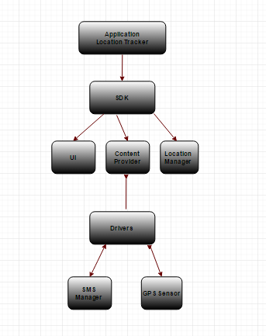

**Screenshots**

Welcome Screen asks you to create a password in the first open of the application and then whenever you open this application you have to use the same password you created on the first use.

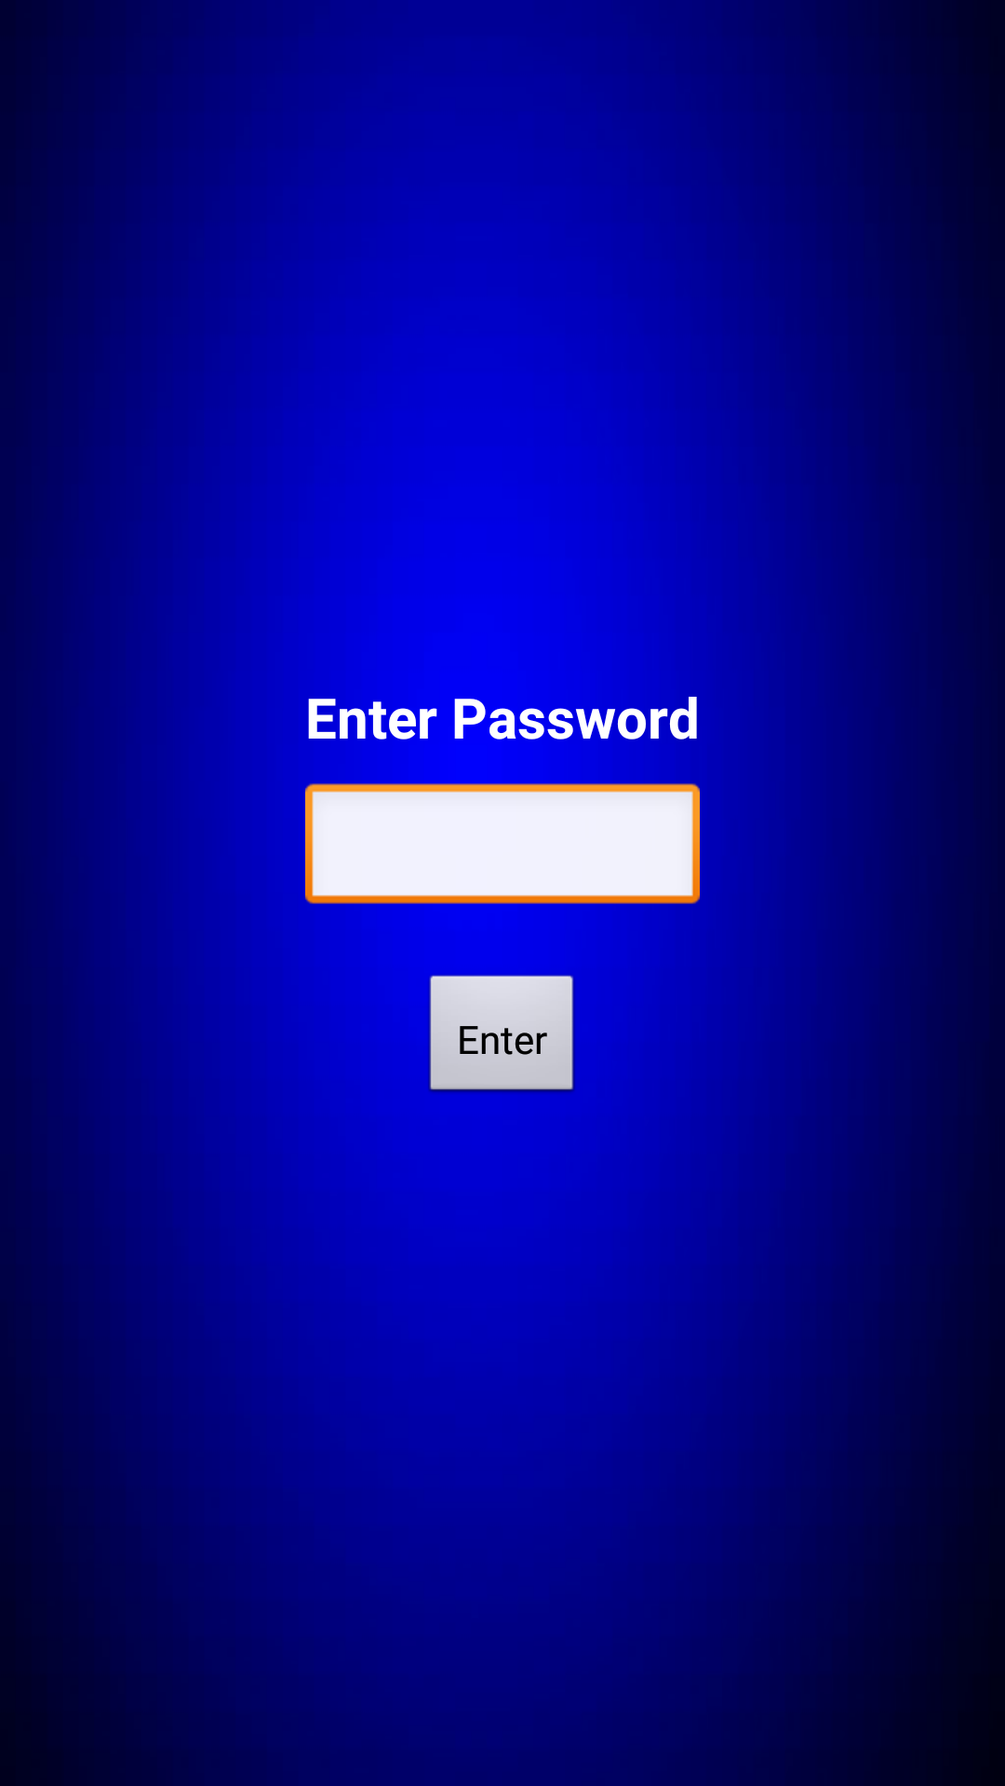

Validation added which checks for the password and gives below error in the form of toast notification if wrong password is entered:

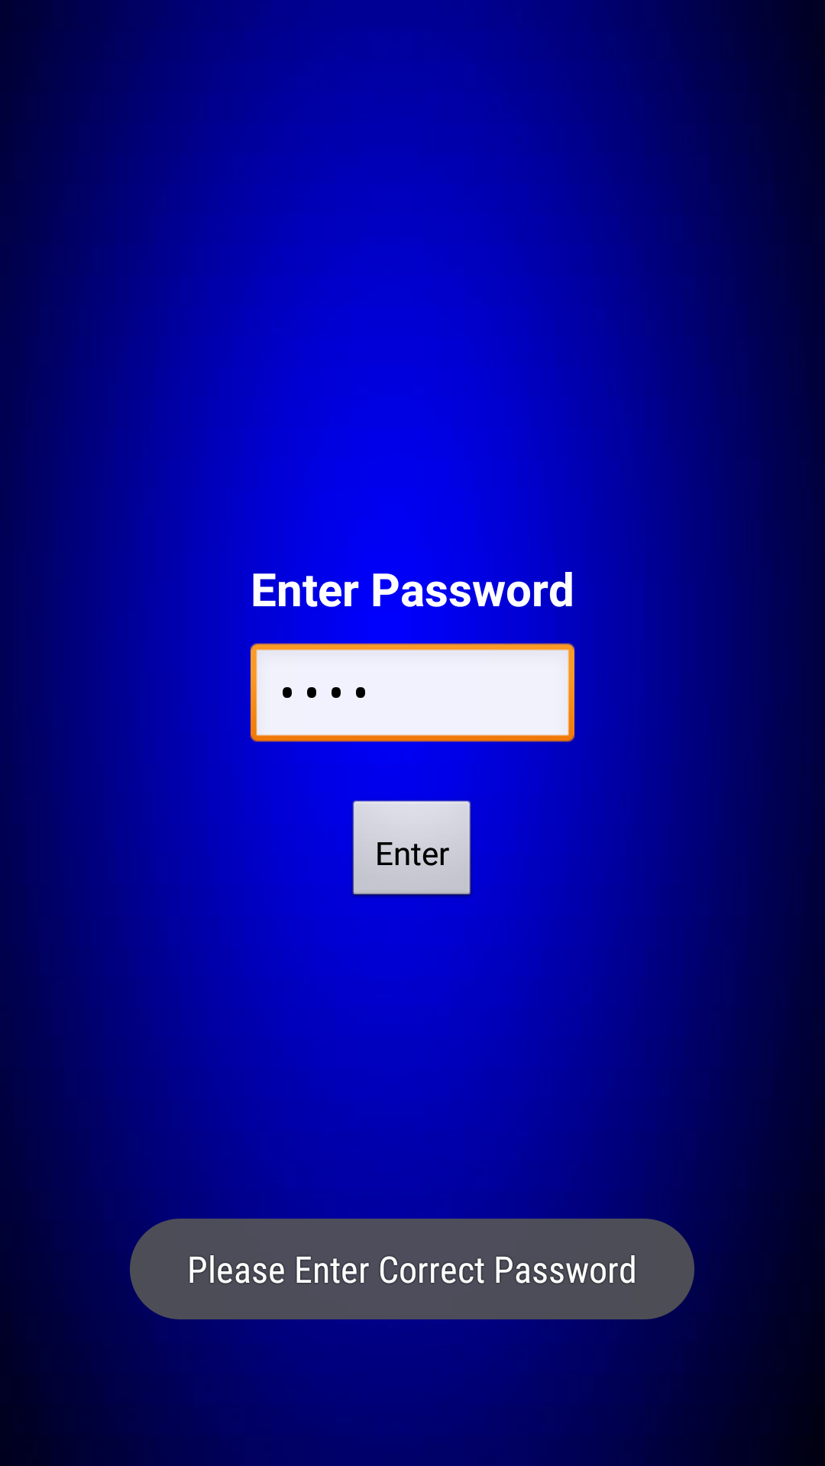

Home Page has a detail which needs to be entered by the user that comprises of Mobile number in which you want this location to be sent via SMS and also time interval under which you want the message to be sent.

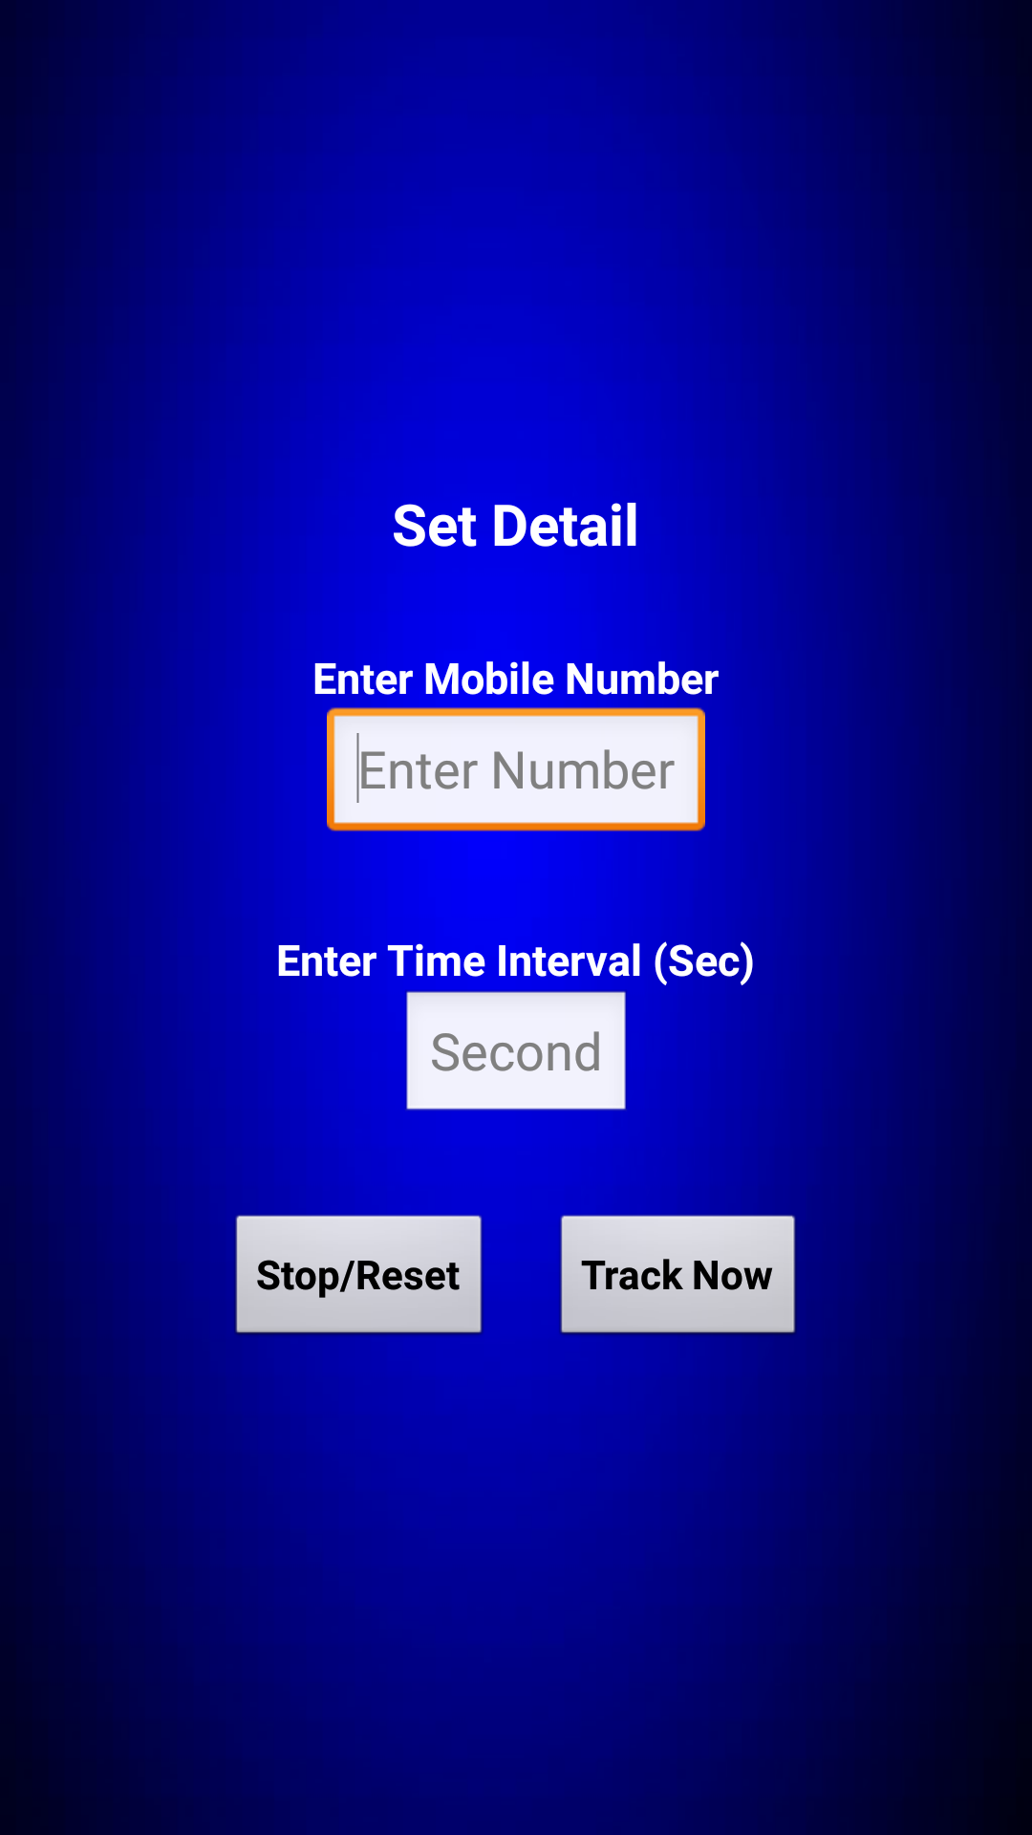

The user enters the details and clicks on Track Now button which gives a message that Tracker has been activated if all the details are correctly validated.

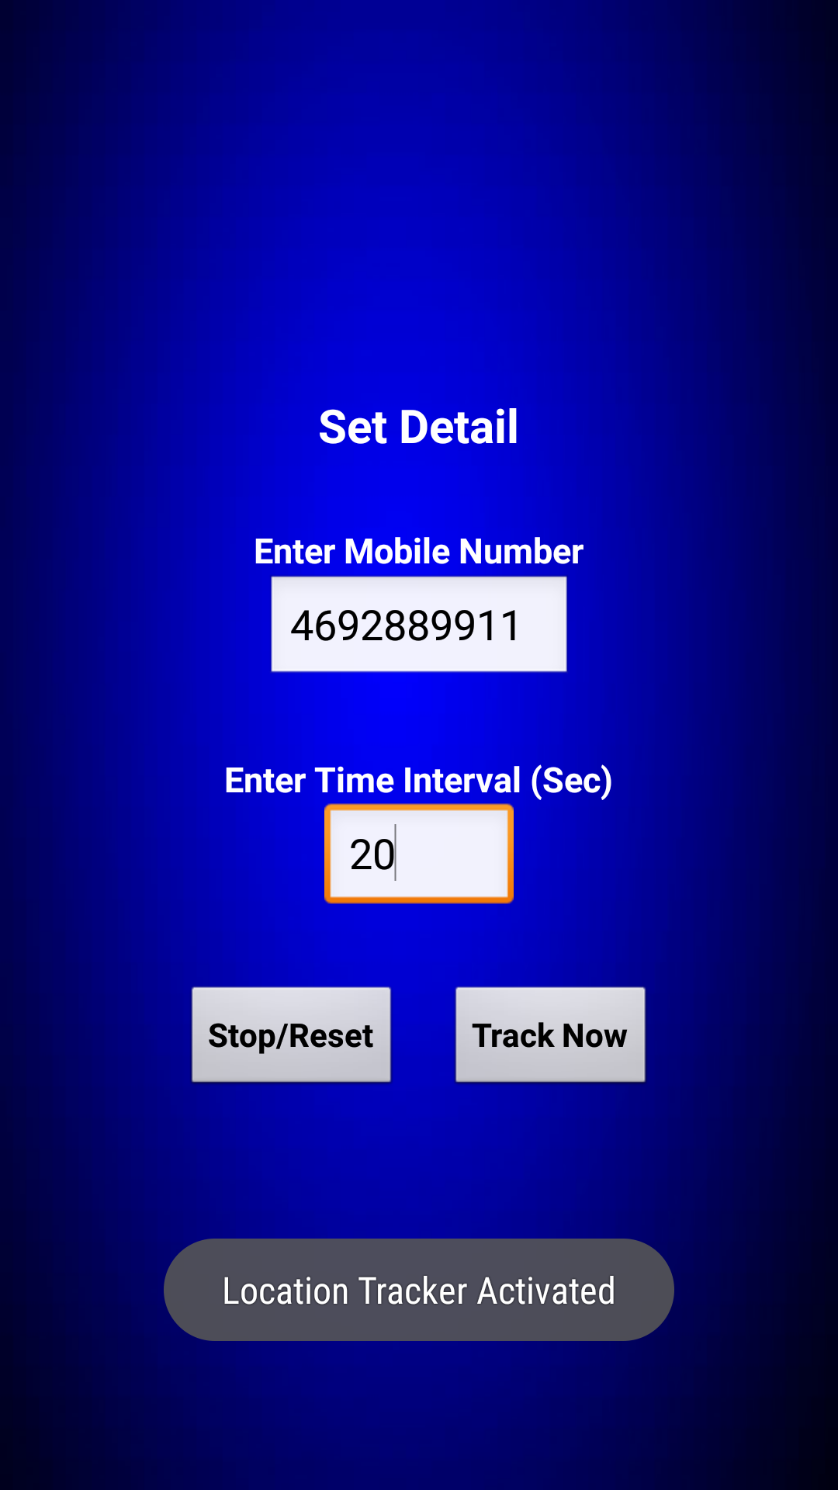

Once the tracker is activated, you can exit the application and it will run in the background. And the location will be sent in the mobile number entered by you and after the time interval you entered. After every time interval, a new message with the updated location will be sent as shown below:

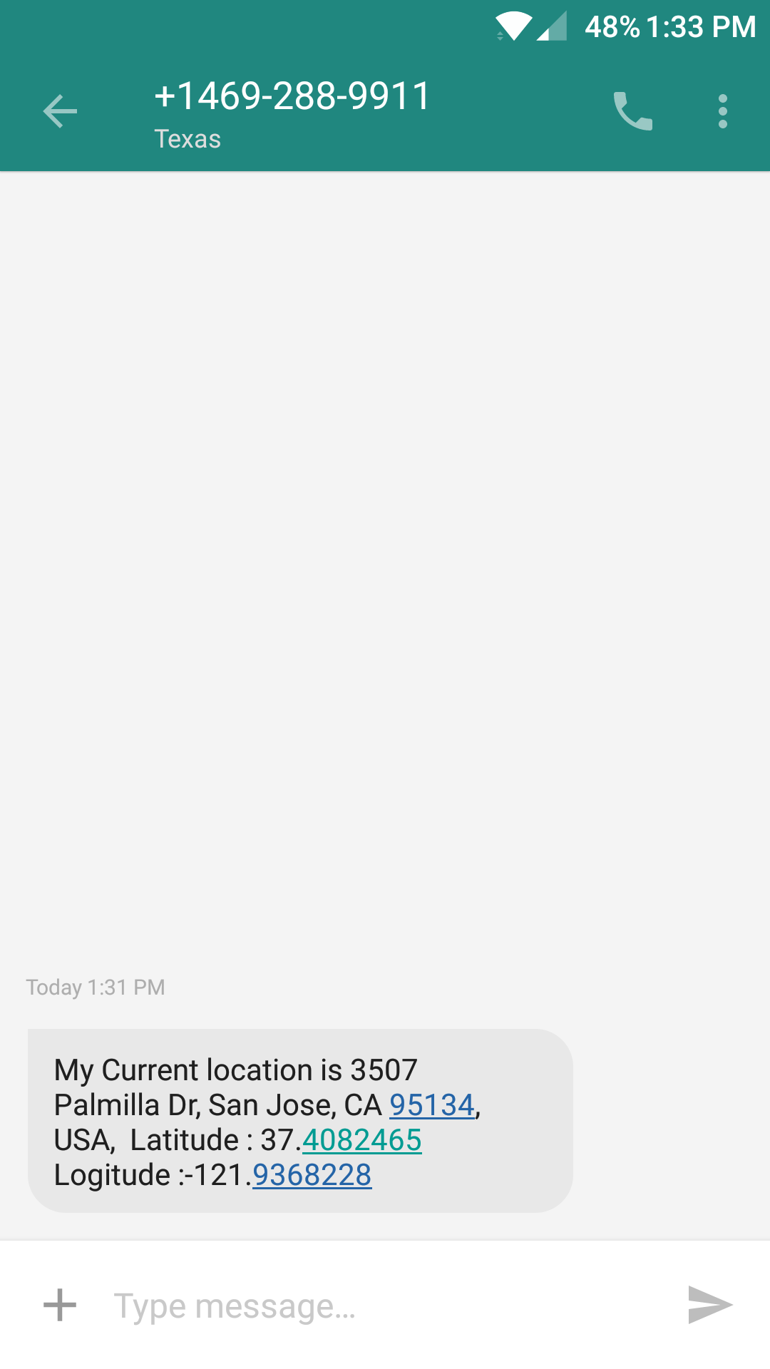

And finally, you can deactivate the tracker anytime you want by clicking on the Stop/Reset button and the toast notification will let you know that the tracker has been deactivated as shown below:

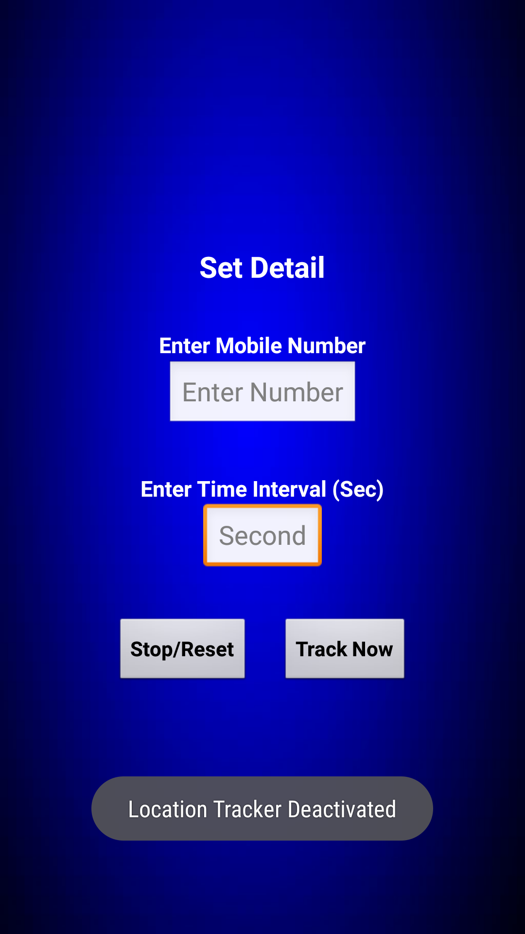

The application also has a validation for the time interval as it cannot be less than 10 seconds.

